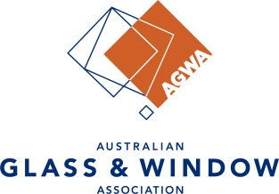
AWA-AGGA LIMITED
ANNUAL GENERAL MEETING

5th ANNUAL GENERAL MEETING
AWA-AGGA Limited
ABN: 57 629 335 208

PROXY FORM

APPOINTMENT OF PROXIES
A member entitled to attend and vote at the general meeting may appoint a person to attend and vote at the meeting as the member’s proxy. A proxy need not be a member. A proxy may be appointed by completing a proxy form (below) and returning it to the Company Secretary so that it is received not less than 48 hours before the commencement of the meeting by:
- post to the Company’s registered office at Suite 101B, Level 1, Building 1, 20 Bridge Street, Pymble NSW 2073 or
- email to ceo@agwa.com.au.
PROXY FORM
I, (insert name) of (insert member company) , (insert member address) hereby appoint (insert name of proxy or the Chairman) to vote on my behalf at the AWA-AGGA Annual General Meeting to be held on 8 April 2024 and at any adjournments of that meeting.
I direct my proxy to vote in the following manner (optional):
Motion 1: That the minutes of the Annual General Meeting held on 12 April 2023 be approved.
For Against
Motion 2: That the financial Report be approved.
For Against
Motion 3: That Nexia Sydney Audit Pty Ltd be appointed as the auditors for AWA-AGGA Limited for 2024.
For Against

Signed

This proxy form must be returned not less than 48 hours prior to the meeting.

